Agenda Item 3/02

= application site



Mallory, Priory Drive, Stanmore | P/1463/20

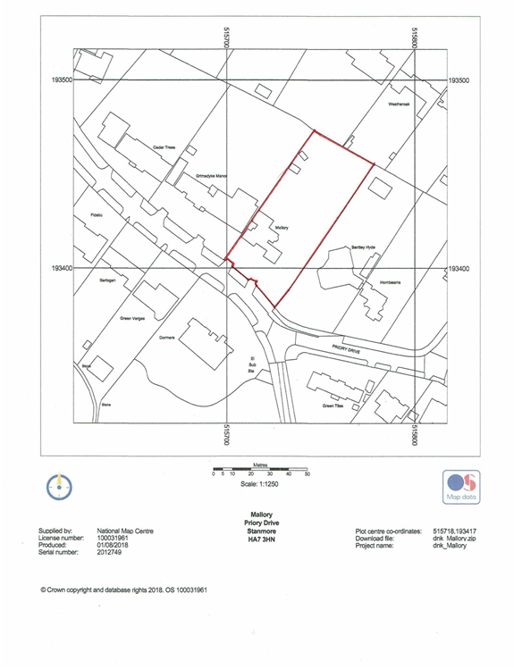

LONDON BOROUGH OF HARROW
PLANNING COMMITTEE

2nd September 2020

APPLICATION NUMBER: | P/1463/20
VALIDATE DATE: | 8TH JUNE 2020
LOCATION: | MALLORY, PRIORY DRIVE, STANMORE
WARD: | STANMORE PARK
POSTCODE: | HA7 3HN
APPLICANT: | MR VEENAY SHAH
AGENT: | STUART CUNLIFFE
CASE OFFICER: | NABEEL KASMANI
EXTENDED EXPIRY DATE: | 4TH SEPTEMBER 2020

PROPOSAL

Single storey outbuilding and linked garage in garden (retrospective)

RECOMMENDATION

The Planning Committee is asked to:

- agree the reasons for refusal as set out in this report, and

- refuse planning permission

REASON FOR THE RECOMMENDATIONS

- The single storey outbuilding and linked garage, by reason of its scale, design, site coverage and the resultant increases in the floor area and footprint, results in a disproportionate addition to the original dwellinghouse, constitutes inappropriate development in the Green Belt and has a harmful impact on the openness and visual amenities of the Green Belt. The applicant has failed to satisfactorily demonstrate that very special circumstances exist to justify inappropriate development and that the harm, by reason of inappropriateness and any other harm, is clearly outweighed by other considerations. The proposal is therefore contrary to the National Planning Policy Framework (2019), Policy 7.16B of The London Plan (2016), Policy G2 of the draft London Plan - Intend to publish version (2019), Core Policy CS1(F) of the Harrow Core Strategy (2012) and Policy DM16 of the Harrow Development Management Policies Local Plan (2013).

- The outbuilding, by reason of its siting, scale and design results in an obtrusive and incongruous form of development to the detriment of the character and appearance of the area and the host property, contrary to the high quality design aspirations of the National Planning Policy Framework (2019), policy 7.6B of The London Plan (2016), Policy D3 of the draft London Plan - Intend to publish version (2019), Core Policy CS1.B of the Harrow Core Strategy (2012), Policy DM1 of the Harrow Development Management Policies Local Plan (2013) and the adopted Supplementary Planning Document Residential Design Guide (2010)

INFORMATION

This application is reported to Planning Committee at the request of a nominated member in the public interest. The application is therefore referred to the Planning Committee as it does not fall within any of the provisions set out at paragraphs 1(a)-1(h) of the Scheme of Delegation dated 12th December 2018.

Statutory Return Type: | (E)21 Householder Development
Council Interest:  Net Additional Floorspace: | n/a  180m²
GLA Community Infrastructure Levy (CIL): | £11,220
Local CIL requirement: | £29,.661

HUMAN RIGHTS ACT

The provisions of the Human Rights Act 1998 have been taken into account in the processing of the application and the preparation of this report.

EQUALITIES

In determining this application the Council has regard to its equalities obligations including its obligations under section 149 of the Equality Act 2010.

For the purposes of this application there are no adverse equalities issues.

S17 Crime & Disorder Act

Policies 7.3.B and 7.13.B of The London Plan and Policy DM1 of the Development Management Polices Local Plan require all new developments to have regard to safety and the measures to reduce crime in the design of development proposal. It is considered that the proposed access does not adversely affect crime risk.

- SITE DESCRIPTION

1.1 The application site is located on the northern side of Priory Drive. The replacement dwellinghouse granted planning permission (under planning application reference P/5568/15 and the subsequent variation of condition application P/1404/18) is currently being constructed on site. A large outbuilding has also been constructed on the site to the south-east of the replacement dwellinghouse

1.2 The site lies within the Green Belt and the Harrow Weald Ridge Area of Special Character. The wider site is covered by TPO 592 Priory Drive (No. 5) Stanmore

1.3 Priory Drive is characterised by detached dwellings, number of which have been substantially extended, set within large plots. Although the dwellings are of varying architectural styles, a number of dwellings feature front projecting end gables and feature staggered front and rear elevations.

1.4 The adjoining neighbouring dwelling to the west, Grimsdyke Manor has width of 48m and has been significantly extended in the past, including a substantial single storey side extension adjacent to the application site. The neighbouring dwelling to the east, Bentley Hyde is located 29m away from the existing eastern flank elevation of the subject dwelling.

- PROPOSAL

2.1 The retrospective application relates to a single storey outbuilding which is located to the south-east of the replacement dwellinghouse. The external shell of the outbuilding has been constructed although it has not been finished internally. The submitted plans show that the outbuilding would be used as a triple garage, gym and gym studio, with associated shower and changing rooms.

2.2 The outbuilding has two crown roofs with a flat roof over the middle component linking the two part. The outbuilding has a maximum height of 4m and an eaves height of 2.5m.

2.3 Permitted development rights for outbuildings under Class E of the General Permitted Development Order were removed under condition 13 of application P/1404/18.

- RELEVANT PLANNING HISTORY

Ref no. | Description | Status & date of decision
P/5568/15 | Redevelopment to provide a two storey replacement dwelling with habitable roofspace & basement; parking and landscaping | Granted: 26/01/2016
P/2313/16 | Certificate of lawful development (proposed): single storey outbuilding in rear garden | Granted: 08/07/2016
P/2314/16 | Certificate of lawful development (proposed): detached triple garage at side | Granted: 08/07/2016
P/1404/18 | Variation Of Condition 2 (Approved Plans) Attached To Planning Permission P/5568/15 Dated 26/01/2016 To Allow Amendments To The Internal Layout Revised Fenestration And Rooflight Details Removal Of Balcony Over Front Porch | Granted: 03/08/2018
P/1977/19 | Variation of condition 2 (approved plans) attached to planning permission P/1404/18 dated 03/08/2018 to allow amendments to the design with a first floor side extension with roof modifications; front porch; alterations to fenestration to first floor | Refused: 2/06/2019  Appeal: Under consideration
P/5137/19 | Variation Of Condition 2 (Approved Plans) Attached To Planning Permission P/1404/18 dated 03.08.2018 for variation of condition 2 (approved plans) attached to planning permission P/5568/15 Dated 26/01/2016 to allow the addition of a front porch with protruding canopy with stone columns and a flats roof and revised fenestration details | Granted: 14/02/2020
P/0444/20 | Details pursuant to condition 13 (general permitted development) attached to planning permission p/1404/18 dated 3/8/2018 for variation of condition 2 (approved plans) attached to planning permission p/5568/15 dated 26/01/2016 | Withdrawn
P/0443/20 | Variation of condition 2 (approved plans) attached to planning permission p/1404/18 dated 03.08.2018 For variation of condition 2 (approved plans) attached to planning permission p/5568/15 dated 26/01/2016 to allow a first floor extension roof modification | Refused: 03/04/2020

- CONSULTATION

4.1 A total of 4 consultation letters were sent to neighbouring properties regarding this application. The minimum statutory consultation period expired on 6th July 2020.

4.2 No comments were submitted following the public consultation.

4.3 Statutory and Non Statutory Consultation

4.4 The following consultations have been undertaken and a summary of the consultation responses received are set out below.

Consultee and Summary of Comments

LBH Drainage Engineer
The applicant should submit drainage details in line with our standard requirements. The applicant should submit Thames Water consent for receiving additional discharge from the new construction. No objection subject to conditions

The Gardens Trust
No Comment

5.0 POLICIES

5.1 Section 38(6) of the Planning and Compulsory Purchase Act 2004 requires that:

‘If regard is to be had to the Development Plan for the purpose of any determination to be made under the Planning Acts, the determination must be made in accordance with the Plan unless material considerations indicate otherwise.’

5.2 The Government has issued the National Planning Policy Framework [NPPF 2019] sets out the Government’s planning policies for England and how these should be applied, and is a material consideration in the determination of this application.

5.3 In this instance, the Development Plan comprises The London Plan 2016 [LP] and the Local Development Framework [LDF]. The LDF comprises The Harrow Core Strategy 2012 [CS], Harrow and Wealdstone Area Action Plan 2013 [AAP], the Development Management Policies Local Plan 2013 [DMP], the Site Allocations Local Plan [SALP] 2013 and Harrow Local Area Map 2013 [LAP].

5.4 While this application has been principally considered against the adopted London Plan (2016) policies, some regard has also been given to relevant policies in the Draft London Plan (2019), as this will eventually replace the current London Plan (2016) when adopted and forms part of the development plan for the Borough.

5.5 The document was originally published in draft form in December 2017 and subject to Examination in Public (EiP) with the Panel’s report published in October 2019. The Mayor of London has considered these recommendations, and has either accepted them or where not, provided justification as to why accepting them would not be appropriate. The Mayor has now submitted to the Secretary of State an ‘Intend to Publish’ version of The Plan. It is for the Secretary of State to determine whether he agrees with the revised Plan and it ought to be published in that form.

5.6 The Draft London Plan is a material planning consideration that holds significant weight in determining planning applications, with relevant polices referenced within the report below and a summary within Informative 1.

6.0 ASSESSMENT

6.1 The main issues are;

Principle of the Development
Character, Appearance and Heritage
Residential Amenity
Flood Risk and Drainage

6.2 Principle of Development

6.2.1 The relevant policies are:
- National Planning Policy Framework (2019)
- The London Plan (2016): 7.16
- The Draft London Plan (2019): G2
- Harrow Core Strategy (2012): CS1F
- Harrow Development Management Policies (2013): DM16

6.2.2 The retrospective application is for a large detached outbuilding which has been constructed to the south-east of the replacement dwellinghouse. Certificate of Lawful Development applications were previously granted for a detached triple garage within a similar location to the existing outbuilding and for a large detached swimming pool. However, the Certificates of Lawful Development were issued with the former dwellinghouse still in situ, having the benefit of permitted development rights for outbuildings under Class E of the General Permitted Development Order (GPDO). It is noted that the shell of the outbuilding was constructed while the former dwellinghouse was still in place. However, the former dwellinghouse was demolished prior to the completion and use of the outbuilding for purposes incidental to the enjoyment of the occupiers of that dwellinghouse, as required by the GPDO.

6.2.3 Upon demolition of the former dwellinghouse and the commencement of engineering works relating to the approved planning permission of the replacement dwellinghouse, the relevant planning conditions attached to the planning permission for the replacement dwellinghouse became binding. Notably, condition 13 of the variation of condition application (P1404/18) and condition 14 of the original permission (P/5568/15) restricted the construction of outbuildings under Class E of the General Permitted Development Order. Clearly, the semi-completed outbuilding was not intended to be or was actually used for a purpose incidental to the enjoyment of the occupiers of the former dwellinghouse in the way allowed for by the relevant legislation. Neither was the outbuilding capable of being constructed under permitted development when the new planning permission was implemented due to removal of permitted development rights. Finally, the outbuilding did not form part of the approved plans or layout for the planning permission of the replacement dwellinghouse. The outbuilding is therefore unauthorised and the subject application is to regularise the breach of planning.

6.2.4 Paragraph 143 of the NPPF states that inappropriate development is, by definition, harmful to the Green Belt and should not be approved except in very special circumstances. The NPPF goes on to inform the determination of whether any particular development in the Green Belt is appropriate or not, by stating in paragraph 145 that ‘A local planning authority should regard the construction of new buildings as inappropriate in the Green Belt’. It does however set out six exceptions to this, including:

the extension or alteration of a building provided that it does not result in disproportionate additions over and above the size of the original building;
(bullet c of Paragraph 145)

6.2.5 When considering any planning application, local planning authorities should ensure that substantial weight is given to any harm to the Green Belt. ‘Very special circumstances’ will not exist unless the potential harm to the Green Belt by reason of inappropriateness, and any other harm resulting from the proposal, is clearly outweighed by other considerations (Paragraph 144).

6.2.6 Case law has established that a domestic outbuilding may be regarded as an extension to a dwelling provided that it forms a ‘normal domestic adjunct’ (Sevenoaks DC v SSE and Dawes). The outbuilding, by reason of its proximity to the house and proposed use (as a triple garage and gym) would physically and functionally relate to the subject dwellinghouse and could therefore be considered to be a normal domestic adjunct.

6.2.7 The relevant test is therefore whether the extension or alteration of a building would result in disproportionate additions over and above the size of the original building (as set out in bullet point c of the exceptions in paragraph 145 of the NPPF). There is no definition of ‘disproportionate additions’ in the NPPF. However, case law has established that this size is the primary test. A numerical/technical and visual assessment is therefore required. Size can be assessed in a number of ways which includes matters of floor space, footprint, height, massing, volume, design and position on the plot. Any or a combination of such factors could contribute towards the extension or alteration of a building resulting in disproportionate additions over and above the size of the original building. However, the courts have held that floorspace is an important indicator.

6.2.8 Planning permission was granted under reference P/5568/15 dated 26/01/2016 for the redevelopment of the site to provide a two storey replacement dwelling with habitable roofspace & basement; parking and landscaping. A section 73 application was thereafter submitted under planning reference P/1404/18 to vary the approved plans (condition 2) to allow amendments to the layout, including a revised footprint of the basement, ground floor and fenestration. A comparison between the footprint and floor area of the approved dwellinghouse being constructed (in accordance with the variation of condition application P/1404/18) compared to the resultant increased in the floor area and footprint as a result of the existing outbuilding is outlined in the table below:

 | Approved Area of Replacement Dwellinghouse (Variation of condition application P/1404/18) | Existing Development (with outbuilding) | % Increase between original approved replacement dwellinghouse and existing with outbuilding
Footprint (m²) | 222 | 405 | 82%
Floor Area (m²) | 438 | 621 | 41%

6.2.9 As demonstrated in the above table, the existing outbuilding when considered as a normal domestic adjunct (i.e an extension to the subject dwellinghouse), would result in a footprint increase of 82% and a floor area increase of 41% beyond that of the approved replacement dwellinghouse. The outbuilding evidently represents a very substantial increase in the overall size of the original building and it cannot reasonably be considered on any view that the subject proposal does not result in a disproportionate addition over and above the size of the original replacement dwellinghouse that is being constructed on site. On this basis, the exception set out at paragraph 145(c) of the NPPF is not met. The proposal is therefore considered to be inappropriate development.

6.2.10 Inappropriate development is by definition harmful to the Green Belt and should not be approved except in very special circumstances. Very special circumstances will only exist if the harm, by reason of inappropriateness, and any additional harm is clearly outweighed by other considerations. A Planning Statement has been submitted with the application which details why the application should be worthy of support. Although not explicitly referenced as very special circumstances (VSC), it is considered that some of the points made should be appropriately considered within this context and are detailed below:

VSC | Officer Comment
The site has the benefit of extant certificate of lawfulness for a swimming pool and triple garage | As detailed above, following the implementation of planning permission for the replacement dwellinghouse, the application site does not benefit from Permitted Development Rights for outbuildings under Class E of the General Permitted Development Order.
The footprint of the subject outbuilding is less than that of the combined garage and swimming pool which were granted under the certificate of lawfulness applications | As the site does not benefit from Permitted Development Rights, the site coverage of the existing outbuilding compared to those which were previously granted Certificate of Lawful Development Certificates does not constitute a fall-back position.
The proposed development would meet Class E of the GPDO, Policy DM16 of the Harrow Development Management Plan Policies, Residential Design Guide and Garden Land Development SPD. | The proposal has been considered in accordance with the relevant policies of the development plan. As detailed in the report, the proposal does not meet the relevant policies in relation to the principle of development or character considerations and therefore is not capable of officer support. Conformity with the GPDO is not material as the site does not benefit from permitted development rights.
The built frontage would be consistent with the adjoining properties and the overall site coverage of development would be less than Bentley Hyde, Grimsdyke Manor and Cedar Trees | It is acknowledged that some of the adjoining dwellinghouses have larger footprints/extensions than that being proposed. However, it is intrusive to note that many of the adjacent neighbouring plots are significantly wider than the subject site. Furthermore, many of the extensions were considered under former policies and not in accordance with the current development plan. No further details have been provided on the date at which the various extensions were granted or the circumstances of each particular case to demonstrate that they were allowed in accordance with the most up to date development plan and relevant/comparable to the subject scheme. The subject application has however been assessed on its own planning merits with regard to the specific context of the subject property and in accordance with the current development plan.
Proposed building is required for a purpose incidental to the enjoyment of the dwellinghouse. | It is acknowledged that the proposed outbuilding would be for a purpose incidental to the enjoyment of the dwellinghouse. However, the provision of a gym and associated facilities would be in the private interests of the occupiers and does not result in an over-riding public benefit. On balance, it is considered the provision of additional gym facilities / garage facilities would not clearly outweigh the harm identified to the Green Belt.

6.2.11 It is considered that the very special circumstances put forward by the applicant fail to clearly outweigh the harm to the Green Belt by reason of inappropriateness and there are no other material considerations that clearly outweigh the identified harm.

6.2.12 The National Planning Policy Framework (2019) makes it clear that an essential characteristic of Green Belts is their openness and permanence. Openness is not defined either within the Framework or in the development plan policies, but is taken to mean an absence of a building or development, and the extent to which a building or development may be seen from the public realm is not a decisive matter. The outbuilding is sited to the south-east of the replacement dwellinghouse and results in approximately 80% of the width of plot/frontage being developed. The overall site coverage and height of the garage with a predominantly hipped roof profile would serve to harmfully detract from the openness of the Green Belt.

6.2.13 For the reasons detailed above, it is considered that the harm caused by the inappropriateness of the development in the Green Belt and its effect on Openness, carries substantial weight. The applicant has failed to demonstrate that very special circumstances exist to justify inappropriate development and that the harm, by reason of inappropriateness and any other harm, is clearly outweighed by other considerations. The proposal is therefore contrary to the National Planning Policy Framework (2019), Policy 7.16B of The London Plan (2016), Policy G2 of the draft London Plan - Intend to publish version (2019), Core Policy CS1(F) of the Harrow Core Strategy (2012) and Policy DM16 of the Harrow Development Management Policies Local Plan (2013).

6.3 Character, Appearance and Heritage

6.3.1 The relevant policies are:
- National Planning Policy Framework (2019)
- The London Plan (2016): 7.4, 7.6
- The Draft London Plan (2019): D3
- Harrow Core Strategy (2012): CS1,
- Harrow Development Management Policies (2013): DM1
- Residential Design Guide SPD (2010)

6.3.2 The outbuilding and linked garage has a combined footprint of approximately 180m² and results in almost 80% of the frontage of the application site being developed. Officers consider that the outbuilding, by reason of its scale, hipped roof design and siting, aligning with the frontage of the replacement dwellinghouse, results in an obtrusive and incongruous form of development to the detriment of the character and appearance of the subject property and the locality. While it is noted that a number of adjacent properties have benefited from extensions resulting in increased built frontage to the application site, these were assessed under previous planning policies.

6.4 Residential Amenity

6.4.1 The relevant policies are:
- National Planning Policy Framework (2019)
- The London Plan (2016): 7.6,
- The Draft London Plan (2019): D2, D4
- Harrow Core Strategy (2012): CS1
- Harrow Development Management Policies (2013): DM1

6.4.2 Given the separation distance afforded between the proposed south-eastern flank wall and the adjacent shared boundary with the neighbouring dwellinghouse Bentley Hyde, the proposal does not have a detrimental impact on the residential amenities of those adjoining occupiers

6.5 Flood Risk and Drainage

6.6.1 The relevant policies are:
- National Planning Policy Framework (2019)
- The London Plan (2016): 5.13, 5.14
- The Draft London Plan (2019): SI13
- Harrow Core Strategy (2012): CS1
- Harrow Development Management Policies (2013): DM10

6.6.2 Had the application been otherwise considered acceptable, it would have been expedient to attach conditions relating to surface and foul water disposal and surface water attenuation, to ensure the development complies with Policy 5.12 of the London Plan (2016) and Policy DM10 of the Harrow Development Management Policies Local Plan (2013).

7.0 CONCLUSION AND REASONS FOR REFUSAL

7.1 The single storey outbuilding and linked garage, by reason of its scale, design, site coverage and the resultant increases in the floor area and footprint, results in a disproportionate addition to the original dwellinghouse, constitutes inappropriate development in the Green Belt and has a harmful impact on the openness and visual amenities of the Green Belt. The applicant has failed to satisfactorily demonstrate that very special circumstances exist to justify inappropriate development and that the harm, by reason of inappropriateness and any other harm, is clearly outweighed by other considerations. The proposal is therefore contrary to the National Planning Policy Framework (2019), Policy 7.16B of The London Plan (2016), Policy G2 of the draft London Plan - Intend to publish version (2019), Core Policy CS1(F) of the Harrow Core Strategy (2012) and Policy DM16 of the Harrow Development Management Policies Local Plan (2013).

7.2 The outbuilding, by reason of its siting, scale and design results in an obtrusive and incongruous form of development to the detriment of the character and appearance of the area and the host property, contrary to the high quality design aspirations of the National Planning Policy Framework (2019), policy 7.6B of The London Plan (2016), Policy D3 of the draft London Plan - Intend to publish version (2019), Core Policy CS1.B of the Harrow Core Strategy (2012), Policy DM1 of the Harrow Development Management Policies Local Plan (2013) and the adopted Supplementary Planning Document Residential Design Guide (2010)

7.3 For all the reasons considered above, and weighing up the development plan policies and proposals, and other material considerations including comments received in response to notification and consultation as set out above, this application is recommended for refusal.

APPENDIX 1: Informatives

- Planning Policies

National Planning Policy Framework (2019)
The London Plan (2016)
5.12, 7.4, 7.6, 7.16
The Draft London Plan – Intend to Publish Version (2019)
D3, G2, SI13, T6.1
Harrow Core Strategy (2012)
CS1, CS7
Harrow Development Management Policies Local Plan (2013)
DM1, DM6, DM10, DM16,
Supplementary Planning Document: Residential Design Guide (2010)

2. Refuse without Pre-App

Statement under Article 35(2) of The Town and Country Planning (Development Management Procedures) (England) Order 2015. This decision has been taken in accordance with paragraphs 39-42 of The National Planning Policy Framework. Harrow Council has a pre-application advice service and actively encourages applicants to use this service. Please note this for future reference prior to submitting any future planning applications.

3 Mayoral Community Infrastructure Levy (provisional)

Please be advised that approval of this application (either by Harrow Council, or subsequently by the Planning Inspectorate if allowed on appeal following a refusal by Harrow Council) will attract a Community Infrastructure Levy (CIL) liability, which is payable upon the commencement of development. This charge is levied under s.206 of the Planning Act 2008 Harrow Council, as CIL collecting authority, has responsibility for the collection of the Mayoral CIL

The Provisional Mayoral CIL liability for the application, based on the Mayoral CIL levy rate for Harrow of £60/sqm is £11,220. This amount includes indexation which is 323/323. The floorspace subject to CIL may also change as a result of more detailed measuring and taking into account any in-use floor space and relief grants (i.e. for example, social housing).

You are advised to visit the planningportal website where you can download the appropriate document templates. Please complete and return the Assumption of Liability Form 1 and CIL Additional Information Form 0. https://ecab.planningportal.co.uk/uploads/1app/forms/form_1_assumption_of_liability.pdf https://ecab.planningportal.co.uk/uploads/1app/forms/cil_questions.pdf
If you have a Commencement Date please also complete CIL Form 6:
https://ecab.planningportal.co.uk/uploads/1app/forms/form_6_commencement_notice.pdf
The above forms should be emailed to HarrowCIL@Harrow.gov.uk Please note that the above forms must be completed and provided to the Council prior to the commencement of the development; failure to do this may result in surcharges and penalties

4 Harrow Community Infrastructure Levy (provisional)

Harrow has a Community Infrastructure Levy which applies Borough wide for certain developments of over 100sqm gross internal floor space.
Harrow's Charges are:
Residential (Use Class C3) - £110 per sqm;
Hotels (Use Class C1), Residential Institutions except Hospitals, (Use Class C2), Student Accommodation, Hostels and HMOs (Sui generis) - £55 per sqm;
Retail (Use Class A1), Financial & Professional Services (Use Class A2), Restaurants and Cafes (Use Class A3) Drinking Establishments (Use Class A4) Hot Food Takeaways (Use Class A5) - £100 per sqm
All other uses - Nil.
The Provisional Harrow CIL liability for the application, based on the Harrow CIL levy rate for Harrow of £110/sqm is £29,661
This amount includes indexation which is 323/224. The floorspace subject to CIL may also change as a result of more detailed measuring and taking into account any in-use floor space and relief grants (i.e. for example, social housing).
The CIL Liability is payable upon the commencement of development.
You are advised to visit the planningportal website where you can download the relevant CIL Forms.
Please complete and return the Assumption of Liability Form 1 and CIL Additional Information Form 0 .
https://ecab.planningportal.co.uk/uploads/1app/forms/form_1_assumption_of_liability.pdf
https://ecab.planningportal.co.uk/uploads/1app/forms/cil_questions.pdf
If you have a Commencement Date please also complete CIL Form 6:
https://ecab.planningportal.co.uk/uploads/1app/forms/form_6_commencement_notice.pdf
The above forms should be emailed to HarrowCIL@Harrow.gov.uk
Please note that the above forms must be completed and provided to the Council prior to the commencement of the development; failure to do this may result in surcharges

PLAN NUMBERS

Site Location Plan, SH07.107 Rev A, SH07.201 Rev B, SH07.202 Rev A, SH07.205 Rev C, Planning Statement

CHECKED

Interim Chief Planning Officer | Orla Murphy pp Beverley Kuchar | 20.8.20
Corporate Director | High Peart pp Paul Walker | 20.8.20

APPENDIX 2: SITE PLAN

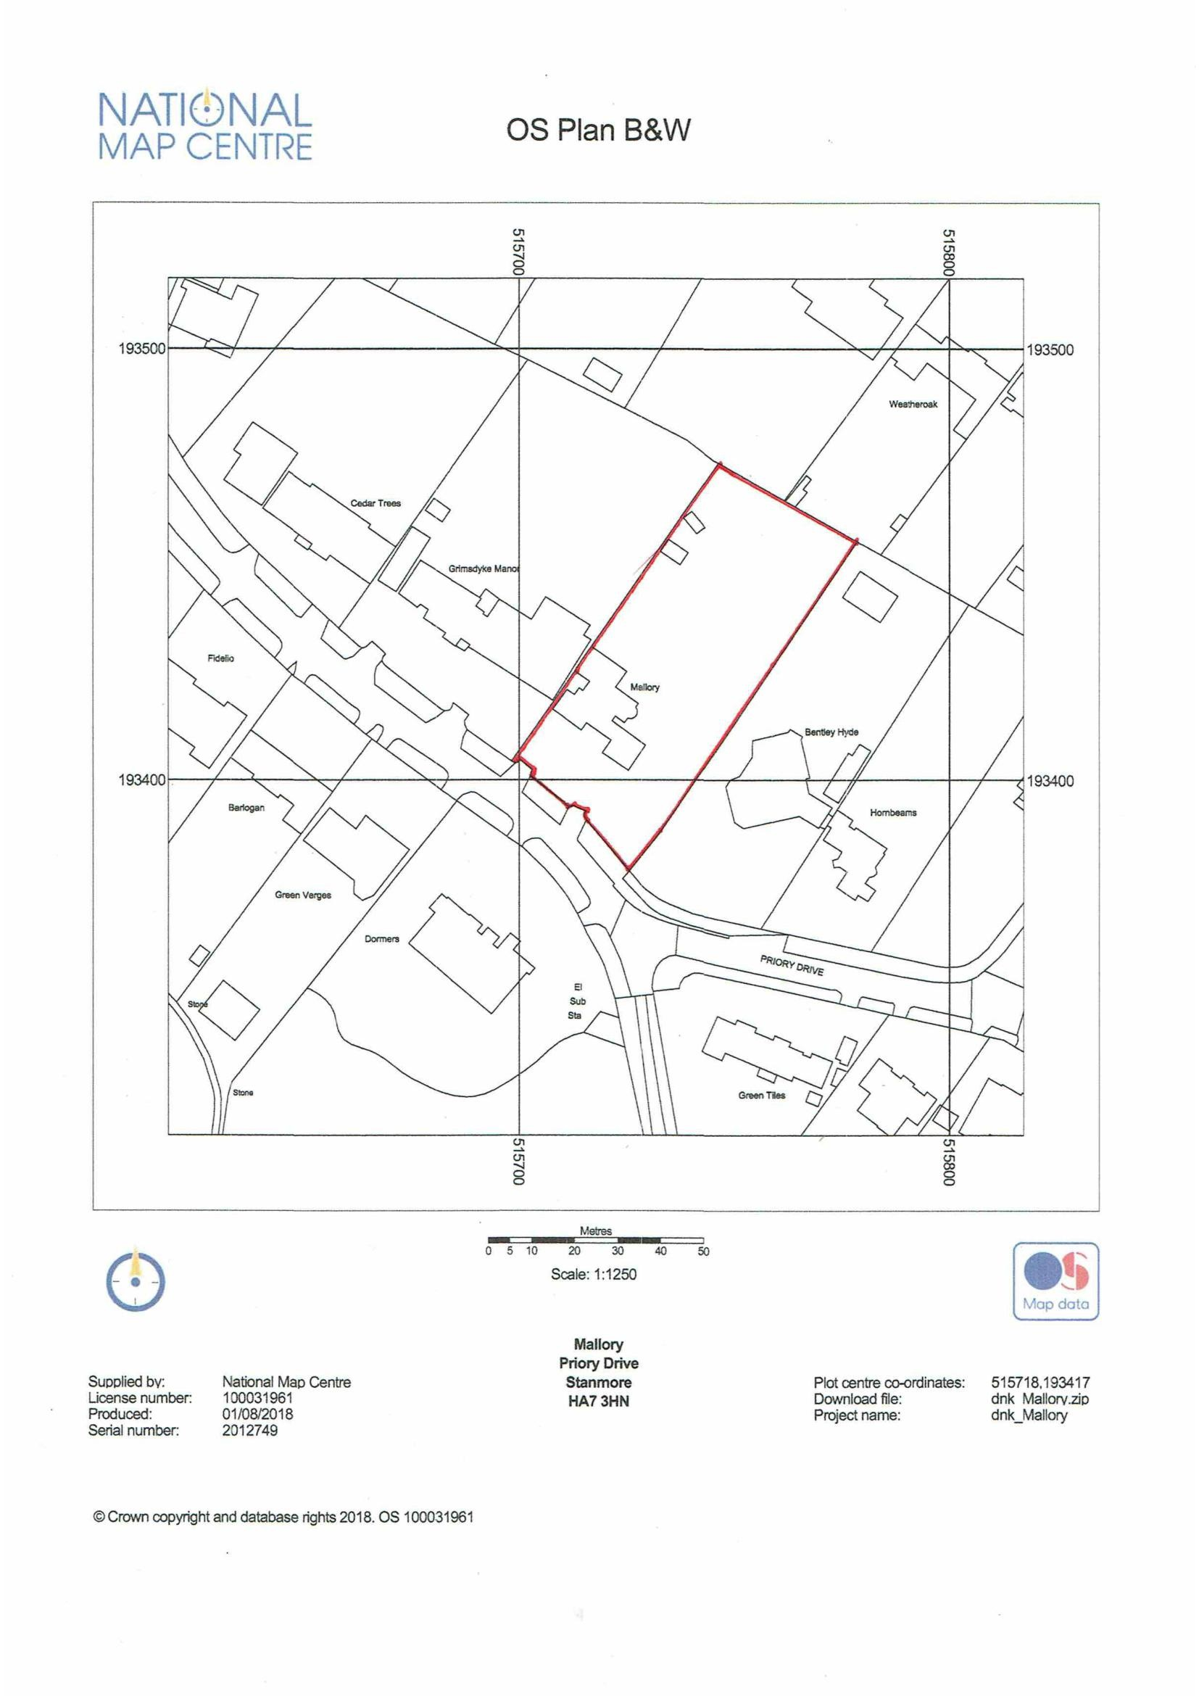
APPENDIX 3: SITE PHOTOGRAPHS

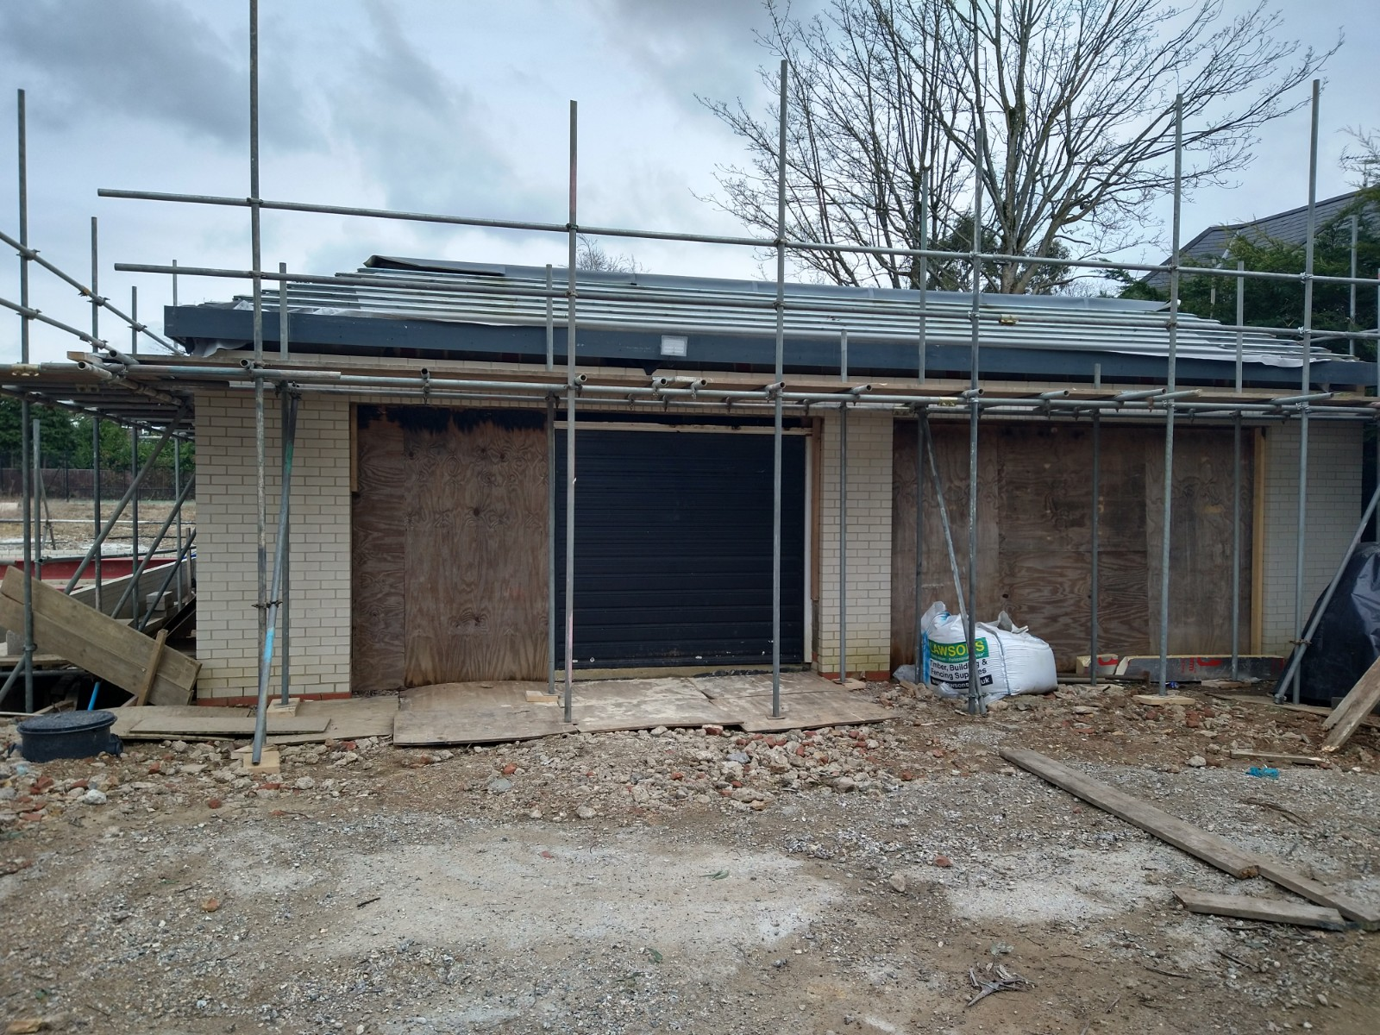

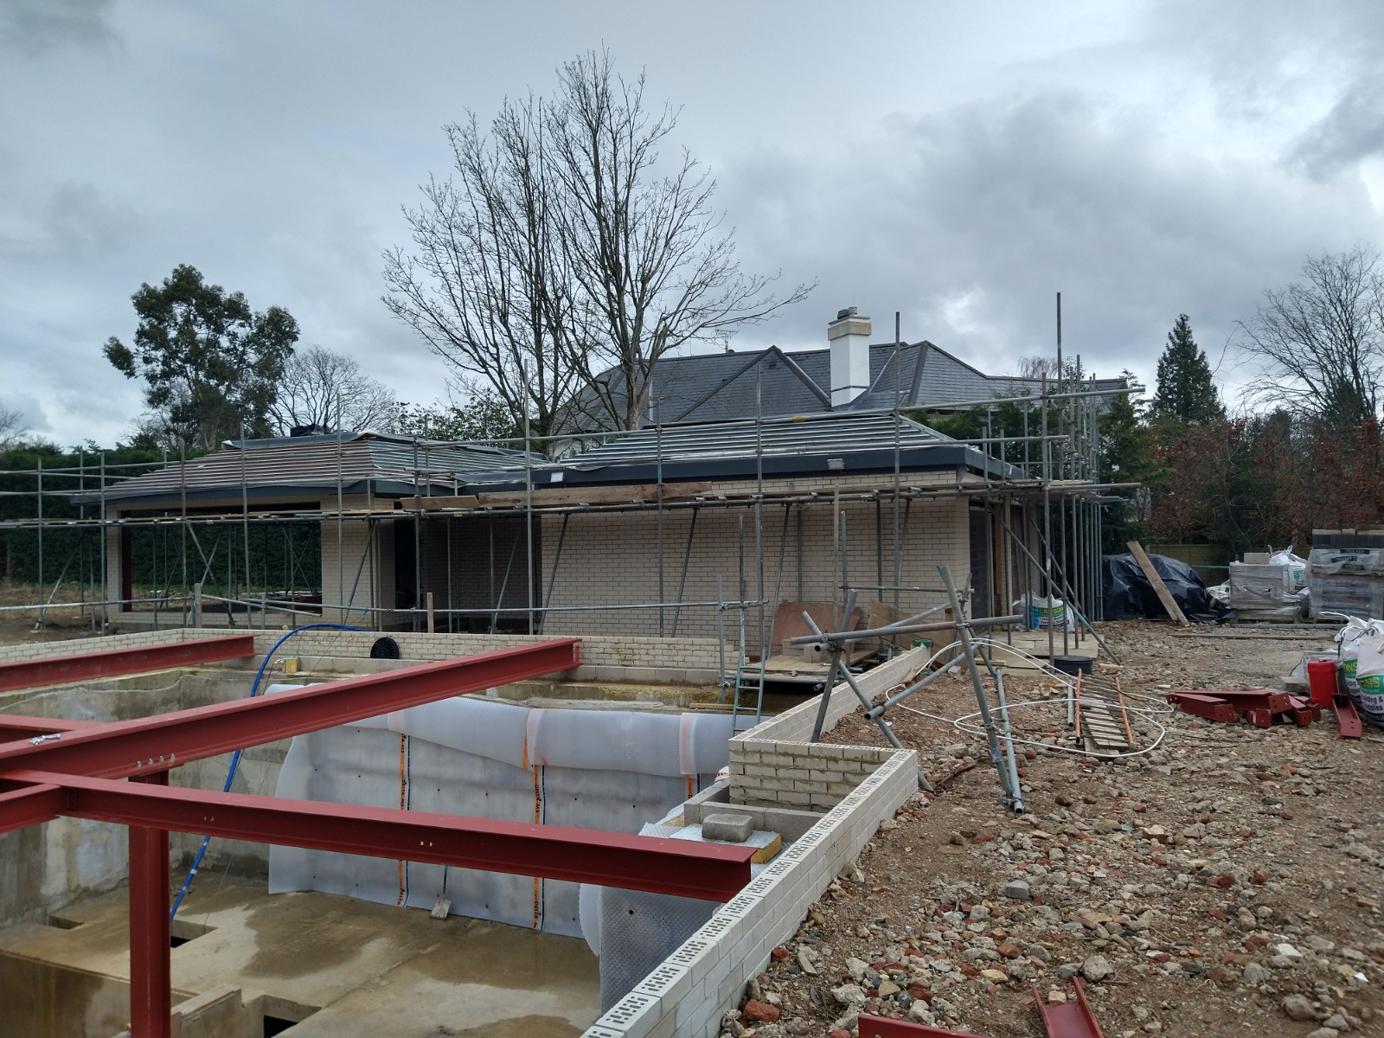

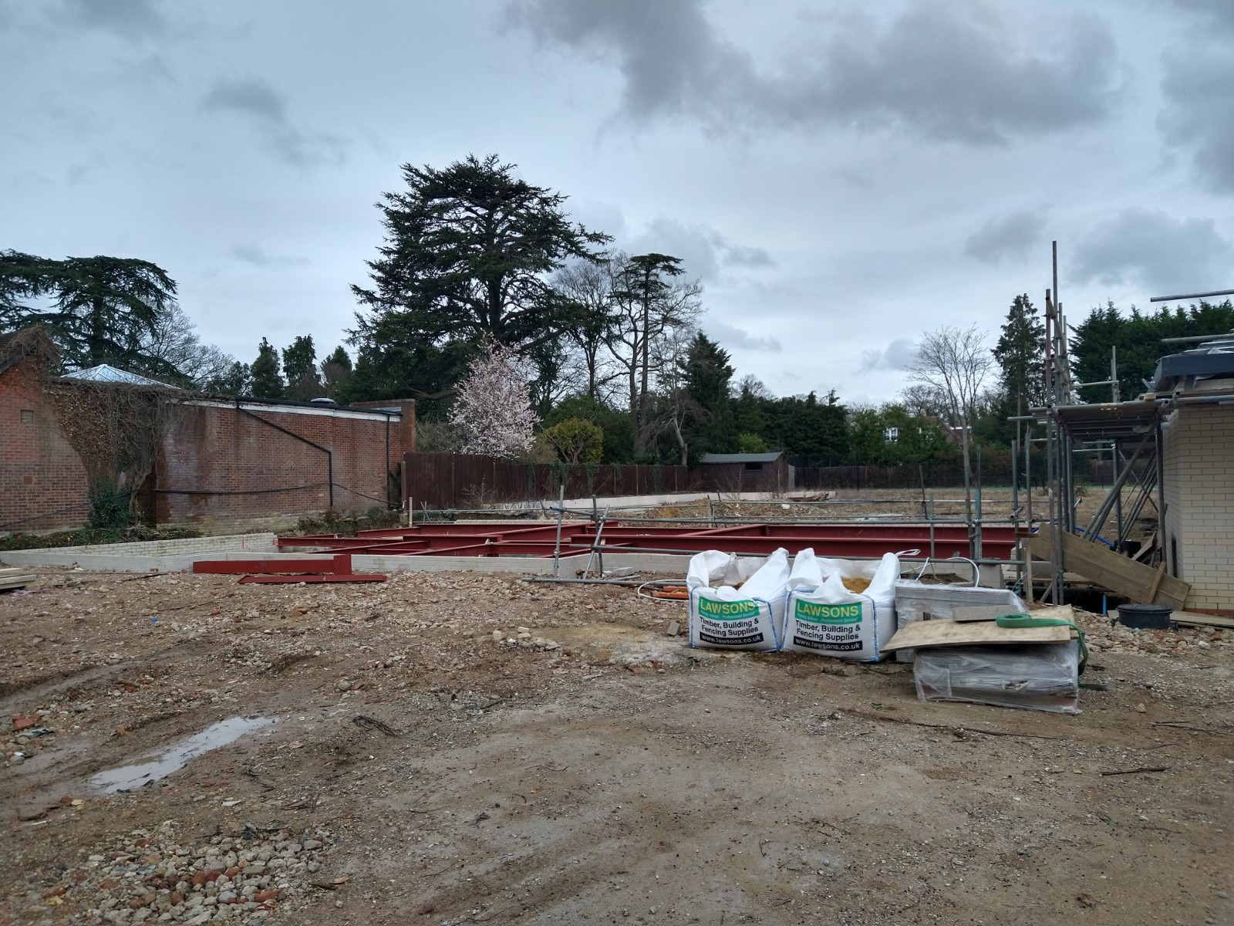
APPENDIX 4: PLANS AND ELEVATIONS



